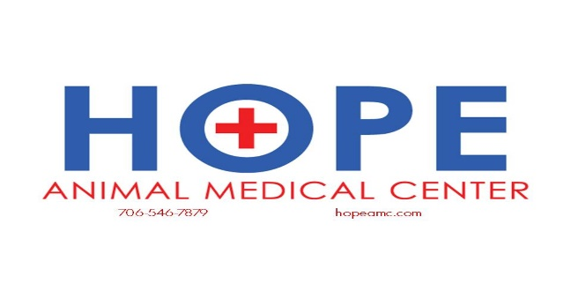

Anesthesia

Fear of anesthesia is one of the most common reasons owners decline necessary dental cleanings or other procedures for their pet. To help our clients ease these fears, we have provided a detailed description of our anesthetic services. At The Drake Center, you can be assured that your pet will be well cared for before, during and after anesthesia.

Initially, each patient is given a thorough physical exam to assess his/her general health. Cardiovascular and respiratory health are particularly important. We will also perform blood tests to make sure liver and kidney functions are normal, since these organs are going to metabolize the drugs we use for anesthesia. If all of these tests are normal, any potential risks of anesthesia will be minimal. When the benefits of the procedure outweigh the minimal risks of anesthesia, we will recommend going ahead the procedure.

It is important to note that repeated anesthetic procedures are necessary for complete treatment in some cases (e.g., severe dental problems, certain surgical procedures or radiation therapy). The risk of anesthetic complications is not increased for patients that undergo multiple procedures.

Before a patient is completely anesthetized, he/she is given pre-medications to help sedate him/her and provide pain control before the procedure is started. Pre-medication is important because it aids in a smooth induction and recovery from anesthesia, as well as reduces the amount of drugs needed during the actual procedure.

After the pre-medication is given, an IV catheter is placed into the patient’s vein. This allows us to use fluids during the procedure. These fluids help us to control the patient's blood pressure and support organ function while under anesthesia. In addition, IV catheters provide rapid access to the circulatory system. This enables us to administer supportive medications as well as prevent or treat any complications that may arise.

Once a patient is anesthetized, we assess multiple parameters to ensure his/her safety:

* An electrocardiogram (EKG) measures the heart rate and rhythm.
* A pulse oximetry monitor measures the oxygen content of the blood. This allows us to know if blood perfusion (delivery) to the tissues is adequate.
* A blood pressure monitor measures systemic blood pressure. This is one of the most important tools we use to make sure blood flow to vital organs is being maintained. If the pressure is low, we can use IV fluids to maintain ideal blood pressure.
* A respiratory monitor measures the rate and pattern of respiration. End tidal carbon dioxide measurement is another tool we use to make sure respiration under anesthesia is appropriate.
* A Bair Hugger blanket is used to maintain the patient's body temperature. This is critical for a smooth anesthetic treatment.
* A Veterinary Technician is assigned to care for each anesthetized patient. All of the above parameters are measured every five minutes by the technician during the procedure. When the procedure is complete, the patient’s temperature, heart rate, respiration and pain control are evaluated every 15 minutes during the recovery process.

When your pet comes home after an anesthetic procedure, you can expect him/her to be groggy and quiet. Some pets may appear agitated and vocalize during the first night. In older pets, this can last a few days. It is very common for pets to refuse food the night of an anesthetic procedure. In some cases, we will send home sedatives if the patient is particularly active or agitated. Most pets are back to their normal activities within a day or two.

We hope that this information helps you feel more comfortable with anesthesia so that you can make informed decisions about your pet’s care. Please let us know if you have any questions or additional concerns.