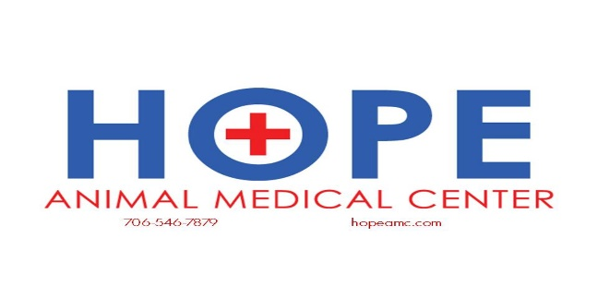

Canine Neutering and Spaying

**Why should I have my female dog spayed?**

Spaying is the removal of the uterus and ovaries. This offers several advantages. Spayed females will no longer have heat periods, will no longer attract male dogs and will no longer be able to become pregnant. Intact male dogs will go to great lengths to mate with females who are in heat, and despite your best efforts, accidents often happen.

It has also been proven that as the unspayed female gets older, she has an increased chance of developing breast cancer and uterine infections. Spaying your dog before she has any heat periods will virtually eliminate this possibility.

If you do not plan to breed your dog, we strongly recommend that she is spayed before her first heat.

**Why should I have my male dog neutered?**

Neutering is the removal of the testicles. This offers several advantages. Intact male dogs are more likely to roam in search of females. They are also more aggressive and likely to fight, especially with other male dogs. However, neutering will not calm down a hyperactive dog or change his personality.

As male dogs age, the prostate gland frequently enlarges and causes difficulty urinating and defecating. They are also often more prone to developing infections (prostatitis) or cancer (prostatic adenocarcinoma). Neutering will greatly reduce the incidence of these diseases.

These surgeries can be performed any time after four months of age. All dogs over 40 pounds should have a hip radiograph to screen for hip dysplasia at the time of surgical altering.

**Is anesthesia safe for my dog?**

We are very confident in the safety of all our anesthetic procedures. We use anesthetics that have minimal cardiovascular side effects compared to other commonly used drugs. All dogs are intubated and placed on oxygen. We use only isoflurane as our inhalant anesthetic.

We take no chances with your dog's safety. All patients are monitored by a skilled technician for the length of the procedure and post-operative recovery period. An EKG monitor is used to assess the dog's heart rate and rhythm and a pulse oximeter is used to assess the oxygenation of the blood while he/she is under anesthesia.

Finally, we feel strongly that management of pain during and after the procedure will decrease your pet’s stress level, contributing to a calmer and more rapid recovery.

**Can you recommend something for pet identification?**

The latest in pet retrieval and identification is microchipping. Many owners elect to have this done at the same time as the spay or neuter. The chip is implanted with a needle, so the process is much like getting an injection. Our scanner, as well as scanners at humane societies and animal shelters across the country, can detect these chips. A national registry permits the return of microchipped pets throughout the United States and Canada.