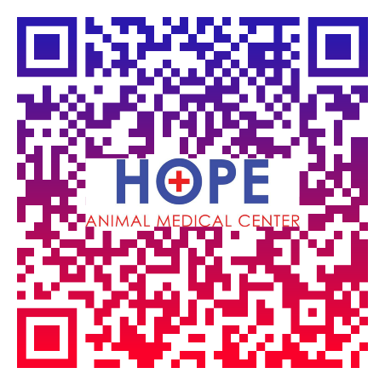**LOCAL EXTERNSHIP OPPORTUNITY**

**LOOKING FOR A LOCAL EXTERNSHIP??**

Hope Animal Medical Center is offering an opportunity for veterinary students to experience a practical, clinical learning environment. Each externship will last two to three weeks, dependent upon the needs of the student. Our Veterinary Externship Program runs year-round and offers veterinary students extensive hands-on learning in the following areas:

• Daily Rounds • Client Relations • Case Work Ups

• Soft Tissue Surgery Shadowing (with opportunities to practice) • General Practice Shadowing • Dentistry Practice • Emergency Critical Care • Business Management and much more

For more information or to set up and externship: Contact Teri Jordan at [terihamc@gmail.com](mailto:terihamc@gmail.com) or call us at 706-546-7879

***Recent Externs include: Jennie Klapko, Alexa Albam, Paige James, Ali Vavlas, Andrew Webster, John F. Smith, Eileen Modzeleski, Ayana Amezquita, Henry Winor, Breunna White, Chelsea Nahous, Eric Erwood, & Nitish Munamala***

**LOCAL EXTERNSHIP OPPORTUNITY**

**LOOKING FOR A LOCAL EXTERNSHIP??**

Hope Animal Medical Center is offering an opportunity for veterinary students to experience a practical, clinical learning environment. Each externship will last two to three weeks, dependent upon the needs of the student. Our Veterinary Externship Program runs year-round and offers veterinary students extensive hands-on learning in the following areas:

• Daily Rounds • Client Relations • Case Work Ups

• Soft Tissue Surgery Shadowing (with opportunities to practice) • General Practice Shadowing • Dentistry Practice • Emergency Critical Care • Business Management and much more

For more information or to set up and externship: Contact Teri Jordan at [terihamc@gmail.com](mailto:terihamc@gmail.com) or call us at 706-546-7879

***Recent Externs include: Jennie Klapko, Alexa Albam, Paige James, Ali Vavlas, Andrew Webster, John F. Smith, Eileen Modzeleski, Ayana Amezquita, Henry Winor, Breunna White, Chelsea Nahous, Eric Erwood, & Nitish Munamala***