Hello, Upcoming and New Graduates! We are looking for a full-time Associate Veterinarian seeking an exceptional work-life balance in the awesome college town of Athens, GA. Our ideal candidate desires a practice that provides best quality medicine, a comprehensive surgical mentorship, and a supportive teamwork environment. We are a bustling, privately owned companion animal hospital with a practicing owner, two full-time associates, and fantastic support staff with a 4:1 staff-to-doctor ratio of RVTs, Veterinary Assistants, Client Care Associates, and Kennel technicians. Hope Animal Medical Center has in-house laboratory capabilities, a well-equipped surgical suite, on-site radiology and ultrasound, pharmacy, surgical laser, cold laser, up-to-date dental equipment, and dental x-ray.

As an Associate Veterinarian at Hope AMC, you are provided with the following benefits:

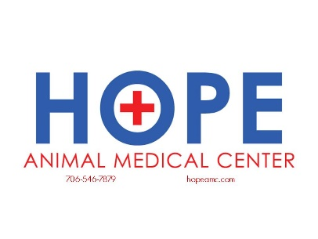 Competitive salary. We do not work off production as we are a collaboration-focused clinic which allows significant growth in a low-pressure environment.

* 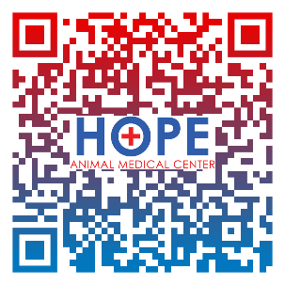 Discounted medical care for personal pets
* CE allowance including time off
* Paid time off for sick and vacation

GVMA, AVMA, GVMA PLIT memberships

* 4-day work week with no weekends or emergency on-call hours
* 401-K with matching contribution
* State Licensing Fees

Access/Membership to VIN, Plumbs phone app, AtDove, Fear-Free, etc.

Our mission of providing exceptional care to exceptional pets starts with having an exceptional team. If you think this sounds like a good fit, please don’t hesitate to contact us to schedule a “meet and greet.”

[terihamc@gmail.com](mailto:terihamc@gmail.com) 706-546-7879

Hello, Upcoming and New Graduates! We are looking for a full-time Associate Veterinarian seeking an exceptional work-life balance in the awesome college town of Athens, GA. Our ideal candidate desires a practice that provides best quality medicine, a comprehensive surgical mentorship, and a supportive teamwork environment. We are a bustling, privately owned companion animal hospital with a practicing owner, two full-time associates, and fantastic support staff with a 4:1 staff-to-doctor ratio of RVTs, Veterinary Assistants, Client Care Associates, and Kennel technicians. Hope Animal Medical Center has in-house laboratory capabilities, a well-equipped surgical suite, on-site radiology and ultrasound, pharmacy, surgical laser, cold laser, up-to-date dental equipment, and dental x-ray.

Hope Animal Medical Center has in-house laboratory capabilities, a well-equipped surgical suite, on-site radiology and ultrasound, pharmacy, surgical laser, cold laser, up-to-date dental equipment, and dental x-ray.

As an Associate Veterinarian at Hope AMC, you are provided with the following benefits:

 Competitive salary. We do not work off of production as we are a collaboration-focused clinic which allows significant growth in a low-pressure environment.

*  Discounted medical care for personal pets
* CE allowance including time off
* Paid time off for sick and vacation

GVMA, AVMA, GVMA PLIT memberships

* 4-day work week with no weekends or emergency on-call hours
* 401-K with matching contribution
* State Licensing Fees

Access/Membership to VIN, Plumbs phone app, AtDove, Fear-Free, etc.

Our mission of providing exceptional care to exceptional pets starts with having an exceptional team. If you think this sounds like a good fit, please don’t hesitate to contact us to schedule a “meet and greet.”

[terihamc@gmail.com](mailto:terihamc@gmail.com) 706-546-7879