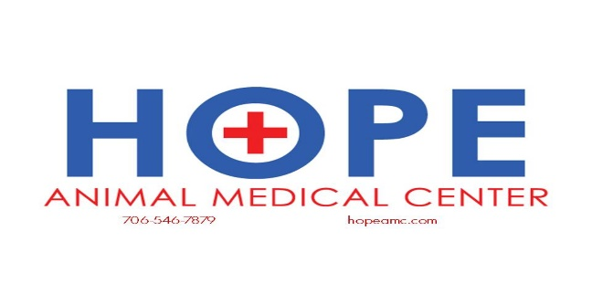

Pet Insurance

Much like human medicine, veterinary care is in a constant state of evolution. New medical advances are available every day that once were not options for our pets.

Because of these advances, our pets are living longer—and healthier—lives than ever before and pet insurance is becoming more common among owners who are looking for ways to proactively manage pet health care costs.

Many companies offer pet insurance, but of course, not all are created equal. At Hope Animal Medical Center, we recommend **Trupanion**. Each company reimburses pet owners based on a percentage of the veterinary expense rather than a pre-selected fee schedule. There are many plans with different types of coverage, and you can find a lot of information at the website below to help you figure out the best option for you. Coverage that is ideal to have is accident & illness coverage for times of emergency or sick visits. Emergency visits can cost $2,000-3,000 per day or more so keep that in mind when picking your plan.   
<https://naphia.org/find-pet-insurance/>

**TRUPANION** | [www.trupanion.com](http://www.trupanion.com/) | (888) 733-2685

Trupanion offers customizable plans with no payout limit and a 90 percent reimbursement rate. Each plan includes an adjustable per-incident deductible between $0 and $1,000. Additional benefits packages are also available.

You may obtain a quote online or connect with a live representative 24 hours a day to guide you through the information. With an exam at The Drake Center, you may also enroll for a free 30-day trial.

* **What is covered:** Trupanion covers veterinary costs due to accidents, illness and injury, as well as hereditary and congenital conditions. This includes diagnostic imaging, surgery, hospitalization, nursing care and treatment, chronic disease management, cancer treatment and referral or specialty care.

In addition, Trupanion covers prescription medications, supplements, therapeutic pet food, orthotic and prosthetic devices, mobility aids and non-routine dental care. Alternative therapies, such as acupuncture, rehabilitation and chiropractic care, are also available for coverage with an additional benefits package.

* **What is not covered:** Trupanion does not cover exam fees or other routine costs, such as preventative care, parasite control, spay/neuter and routine dental care (scaling, cleaning and polishing). Pre-existing conditions are also excluded from coverage.