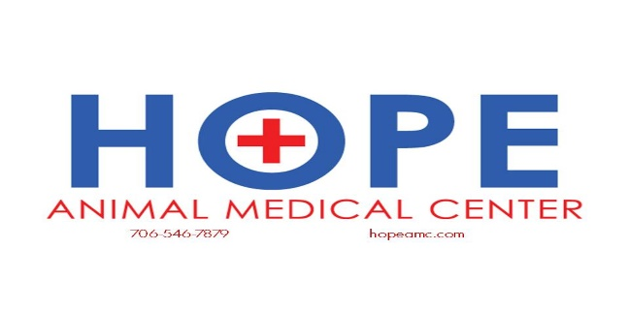

Senior Pet Care

On average, pets age seven times faster than people. This means that most dogs and cats reach adulthood by age two and middle age by four. By age seven, most dogs—particularly larger breeds—are entering their senior years!

Because dogs and cats age so rapidly, health problems tend to progress faster in pets as well. The risk of many diseases, including dental disease, heart disease, diabetes, kidney disease, arthritis and cancer all increase with age and have the potential to worsen within a matter of weeks. Even pets that appear normal can have an underlying problem, which is why regular visits to the veterinarian are crucial for older pets.

**Common medical conditions in senior pets include:**

* Periodontal disease
* Gingivitis
* Inflammatory, degenerative and cancerous liver disease
* Kidney failure, stones or infection
* Heart disease
* Pneumonia
* Bronchitis
* Emphysema
* Arthritis
* Hip dysplasia
* Back disease
* Diabetes mellitus
* Hyperthyroidism
* Hypothyroidism
* Cancer
* Cataracts
* Glaucoma
* Inflammatory bowel disease
* Pancreatitis
* Colitis

Early detection can help prevent disease and minimize suffering of an older pet. At Hope Animal Medical Center, we recommend annual exams and yearly wellness bloodwork for all pets seven years and older. For more information or to schedule an appointment, please call (706) 546-7879.