# Monitoring Your Dog’s Sleeping

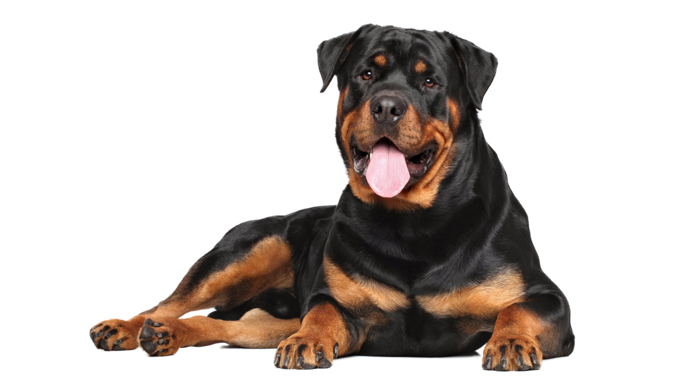

**Respiratory Rate**

Tracking sleeping respiratory rates (SRR) at home is an excellent

way to monitor for early signs of congestive heart failure, as well as to assess your dog’s response to medication changes.

The chart on the reverse side is designed to make tracking your dog’s SRR easier.

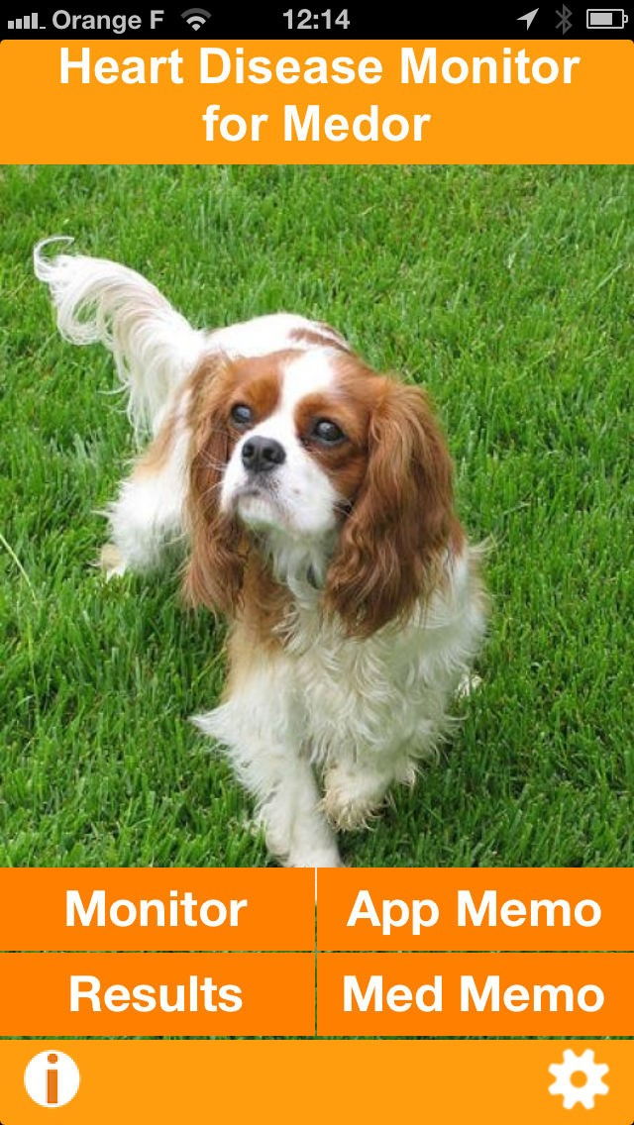

**DIRECTIONS**

When your dog is sleeping or resting soundly, count the number of times his/her chest goes up and down over 15 seconds. Multiply this number by 4 to calculate breaths per minute.

A normal sleeping respiratory rates is less than 30 breaths per minute. Sleeping respiratory rates greater than 50 breaths per minute, increased respiratory effort, or open-mouth breathing may indicate an emergency and

your pet should be evaluated by a veterinarian immediately.

**Apps to Help Monitor Sleeping Respiratory Rate at Home**

If you are having difficulty counting the breaths while keeping time, there are several phone apps available to help you. If you have an iPhone, the Cardalis app can be easily downloaded for free.

Other apps include Heart2Heart Canine RRR and Your Dogs Heart Resting Respiratory Rate.



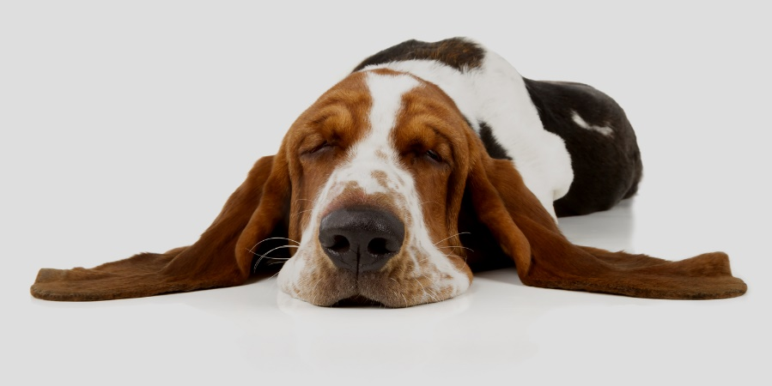

**HOPE ANIMAL MEDICAL CENTER**

Exceptional Care for Exceptional Pets

1150 Mitchell Bridge Road

Athens, GA 30606

706-546-7879

info@hopeamc.com

**SLEEPING RESPIRATORY RATE**

## Your Dog’s Name Please monitor respiratory rates times daily / weekly.

**Time**

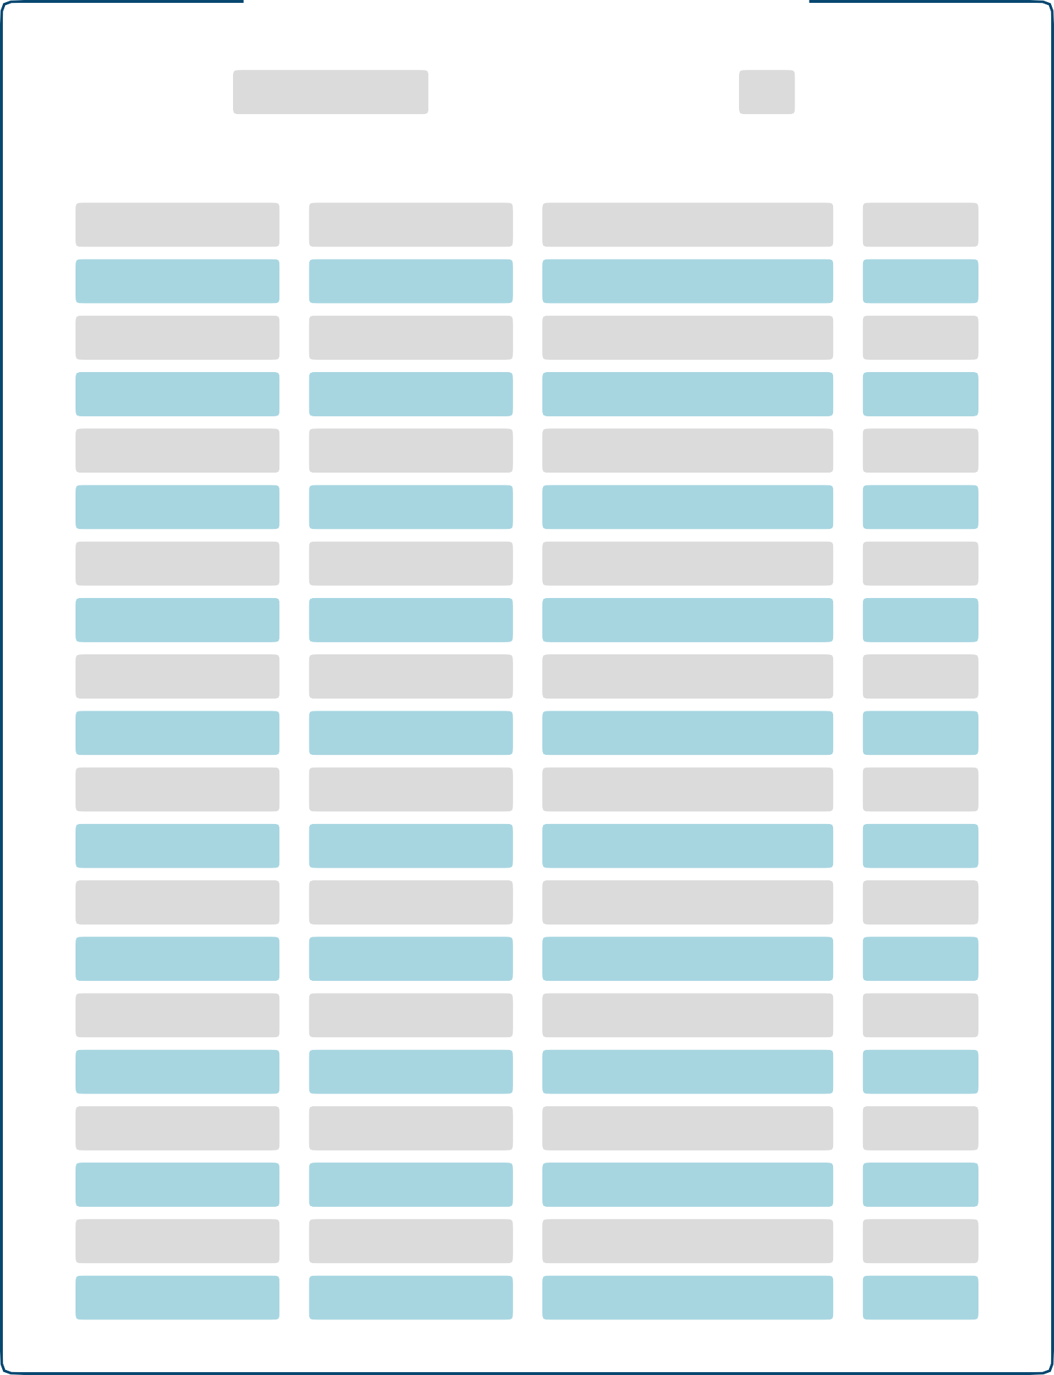**Date**

**Respiratory Rate (breaths per minute)**

**Sleeping (S) or Resting (R)**