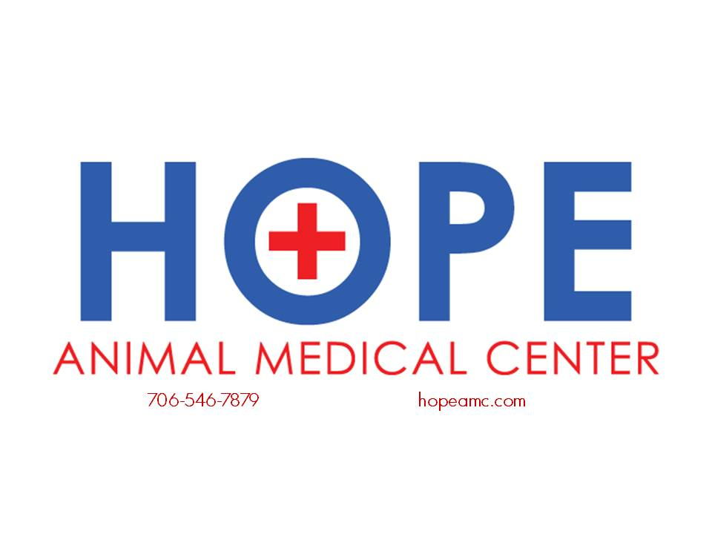

VETERINARY MEDICAL TREATMENT/SURGERY CONSENT AND RELEASE FORM Please note: All pets entering the Hope Animal Medical Center must be current on recommended vaccinations and free of external parasites. If your pet has not been a patient previously at our hospital, failure to provide documented proof of vaccination history may result in your pet being vaccinated. If external parasites are found on your pet during hospitalization, they will be treated at the owner’s expense.

Client’s Name: __________________________ Pet’s Name: _________________________

Procedure(s) to be performed: _____________________________________________________ ______________________________________________________________________________

____ I authorize the Hope Animal Medical Center’s (also referred to as “HAMC”) veterinary staff to perform the above-mentioned medical procedure(s) and/or treatment on my pet. I authorize and consent for HAMC’s staff to hospitalize, sedate, anesthetize, prescribe medication, Xray, ultrasound and/or perform any treatment as they may deem necessary for my pet with relation to the above procedure(s).

____ I have been informed of the risks and the benefits associated with performing the above medical procedure(s) on my pet. I acknowledge and understand that the above stated procedure(s) bear(s) certain known and unknown risks or unanticipated risks, which could result in injury to my pet, including, the possibility of its death. I also understand and realize that additional risks of the procedure(s) may include adverse reactions to my pet, such as, but not limited to, allergic reactions from medications and/or complications presenting during (or after) surgery.

____ I acknowledge and understand that risks and complications always exist with animals undergoing anesthesia and/or surgery and that I have been encouraged to ask questions and discuss any concerns I have regarding such risks and complications with the attending veterinarian - before signing this document and before any treatment and/or surgical procedure is initiated.

____ I acknowledge that the veterinarian is not able to provide me with a guaranteed outcome for the veterinary medical treatments to be performed on my pet. I acknowledge that the veterinarian has provided me with information about the many factors that play a role in determining the outcome of veterinary care and treatment. These associated factors include, but are not limited to, my pet’s age, breed, genetics, ability to heal, stage of the illness/disease, and my ability to follow pre-surgical instructions and provide the recommended at-home care for my pet. I expressly agree to release HAMC, its agents and its representatives, from liability for any/all damages to my pet and to hold HAMC, its agents and its representatives harmless from any and all liability (except in the case of gross negligence) associated with the above-mentioned medical/surgical procedures being performed on my pet.

____ I acknowledge that the veterinarian at HAMC has recommended that Post-op Physical Therapy will be necessary for the reduction of risk in regards to failure of the procedure.

____ I agree to pickup my pet from Hope Animal Medical Center as soon as notified by the hospital staff unless other prior arrangements have been made (such as boarding). I understand that failure to retrieve my pet (unless other arrangements have been made) may be considered “abandonment.” If my pet is considered abandoned, I understand and agree that my obligation to Hope Animal Medical Center for full and complete payment of all medical care, boarding, and related fees shall remain my sole responsibility, regardless of the outcome of the medical procedure(s).

____ I understand and agree that full payment to Hope Animal Medical Center is due upon completion of the surgical/medical treatment (including any related charges as herein described). In the event that my pet’s health- insurance company fails to provide payment to the clinic, for whatever reason(s), I agree to assume sole responsibility for providing full payment of all fees related to my pet’s medical care, immediately upon request by HAMC.

______ I acknowledge that if my pet is hospitalized overnight at this facility, I understand that veterinary care during nighttime hours and/or weekends is provided at the discretion of the attending veterinarian. Continuous presence of personnel may not be provided during these hours.

**If I desire that my pet have supervision when this facility is closed, I elect to**:

1. _______ pick up my pet and provide care in my home, in which case I accept all the risks involved.

or

1. _______ have my pet transferred to a local emergency clinic where overnight veterinary supervision is

available at my expense. (Initial “a” or “b”). [CONTINUED ON NEXT PAGE/OPPOSITE SIDE]

______I certify that my pet has not eaten any food or drank liquids since midnight last night. HOWEVER, if I am unsure whether my pet has had water or eaten anything today, I accept all responsibility for assuming the increased risks of complications that can arise from my pet’s aspiration (such as inhalation of regurgitated stomach contents) while under sedation, anesthesia, or while recovering from anesthesia – and do hereby agree to hold Hope Animal Medical Center. and its agents, harmless from any and all liability associated with such increased risk for potential complications (incl. possibility of death) to my pet.

____ I understand and acknowledge that I can terminate treatment of my pet, at any time prior to the procedure, by verbally contacting the veterinarian.

____ I understand and have been advised that, during the performance of the above-mentioned procedure(s), unforeseen conditions and circumstances might arise or might be revealed that necessitate (1) an extension of the above procedure(s) and/or (2) different procedure(s) being required in addition to the above-mentioned medical procedure(s). Therefore, having been advised of this possibility, I authorize the performance of, such procedure(s) as are necessary in the exercise of the veterinarian’s professional judgment - within the limits (if any) described below.

In case of emergency, I understand that HAMC will make every attempt to contact me by phone. However, depending upon the circumstances, in the event that they are unable to contact me prior to rendering emergency treatment on my pet, the following decisions have been made by me regarding the rendering of emergency and/or resuscitative care and treatment to my pet:

HAMC’s staff _____has ______ does not have (initial applicable phrase) my permission to provide any emergency treatment as the attending veterinarian or technician deems necessary.

______ I agree to pay for all related fees related to such emergency treatment.

OR

______ I agree to pay no more than $_________________ related to such emergency treatment. (Initial the approved choice and cross out the inapplicable phrase.)

OR

Please do NOT resuscitate my pet. ___________________________________ (Signature)

Upon my signature below, I certify that: (1) I have read all of the above statements; (2) I understand and agree with the above statements, as shown by the presence of my initials alongside the statements; (3) I have been informed of the potential risks and benefits related to these medical procedures and treatment; (4) **prior to signing this form**, I have had all my questions answered and concerns addressed by the veterinarian, to my satisfaction; and (4) I consent to the procedure(s) being performed on my pet.

Owner’s signature: _________________________________ Date: ________________

Telephone numbers where I may be contacted today: (Please provide at least two phone numbers, especially in case of an emergency) _______________________ ______________________ ______________________